# Algorithm for file updates in Python

## Project description

As an entry security analyst and with the help of google coursera practicing coding with python, I've been developing an algorithm and parsing a file containing IP addresses that are allowed to access restricted and removed addresses that no longer have access.

## Open the file that contains the allow list

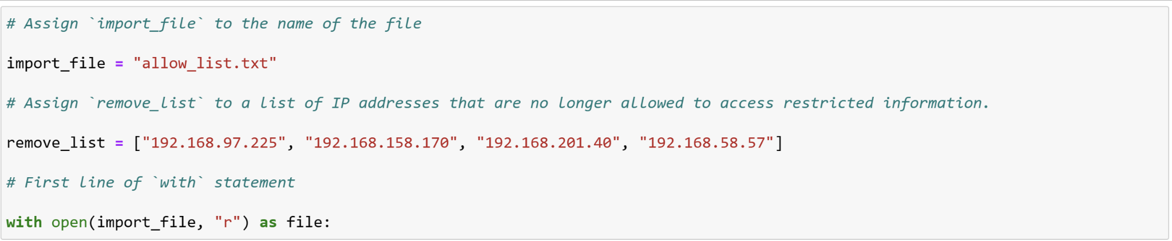

I had put the ip addresses in remove_list and completed the with function with the two arguments of import_file and “r” as a file.

## Read the file contents

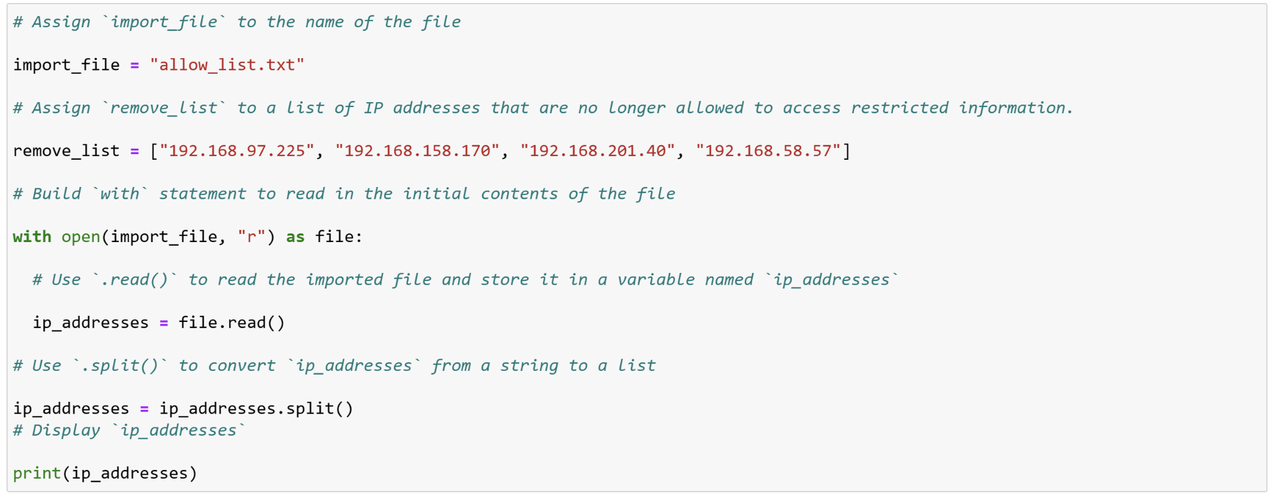

After i finish the with function, i use ip_addresses equal to file.read and then i split the ip_addresses and pass it to the new ip_addresses.

## Convert the string into a list

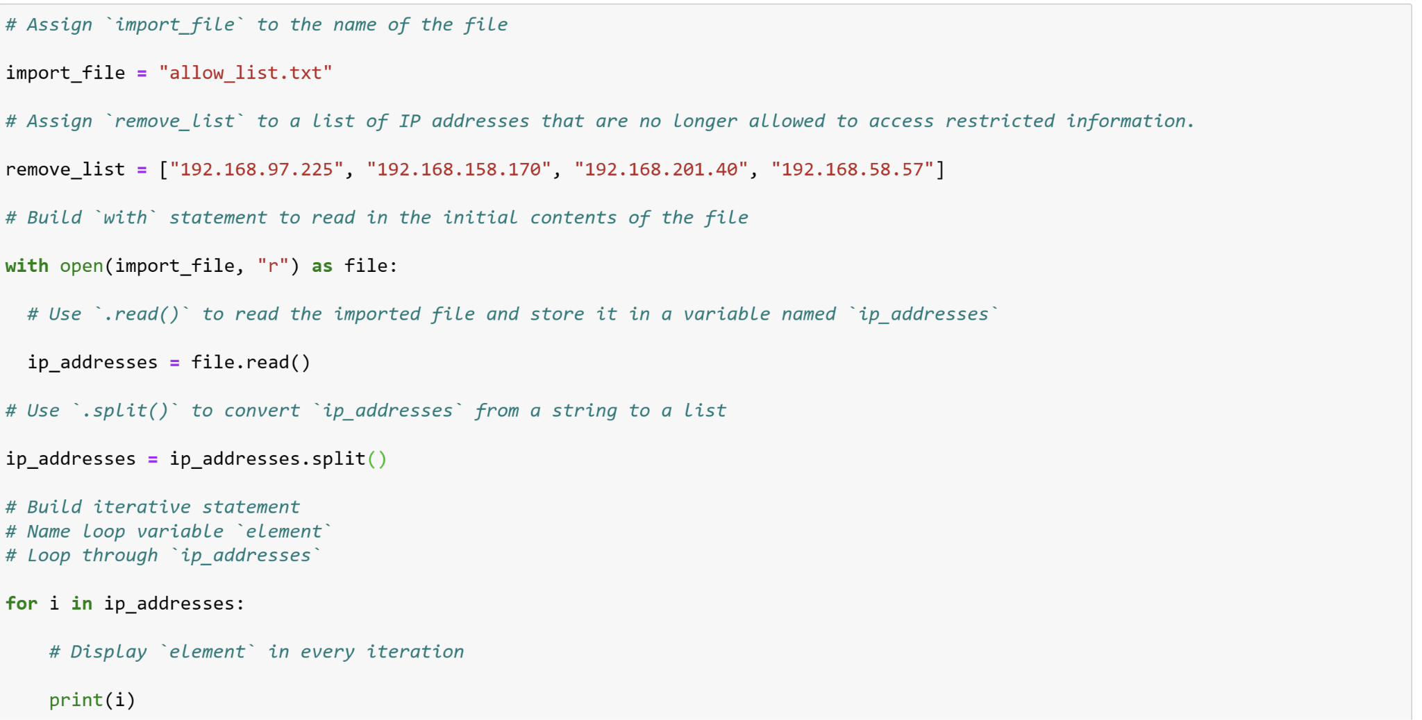

## Iterate through the remove list

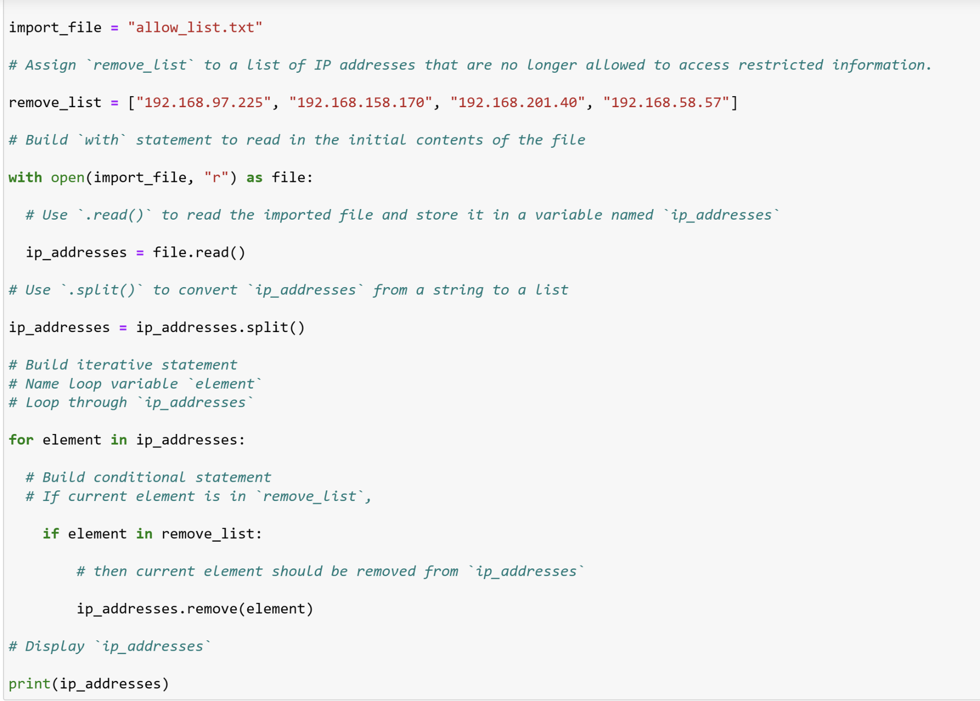

I use for loop and the element variable in ip_addresses and i did conditional statement the if the element is in the remove_list make it remove and displayed it with the print function.

## Remove IP addresses that are on the remove list

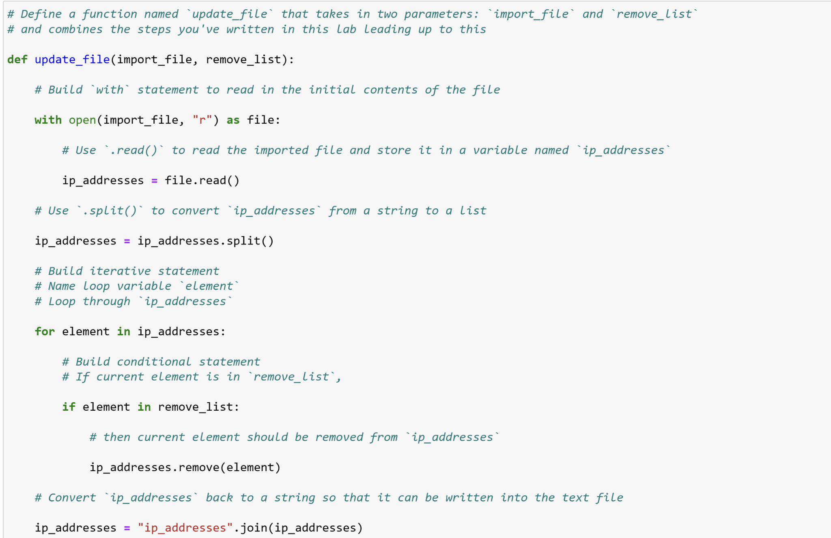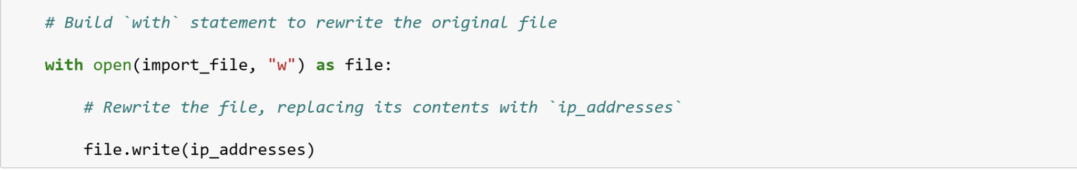

To make remove the ip addresses that are on the remove it used def function first and updated the file to make it, it use two arguments after that it use with function and read the ip addresses and then split it to make it a list after that it use for function and the ip addresses has been stored in element so if the element is in the remove list it will remove with the comparison of ip_addresses and use the .remove function after that it did use the with function use the import_file and it write it on ip_addresses

Update the file with the revised list of IP addresses

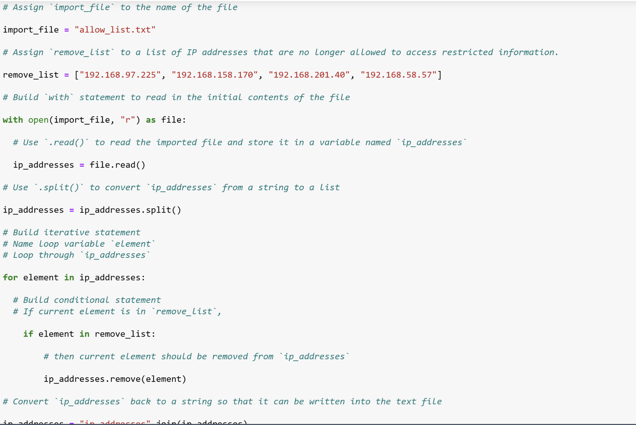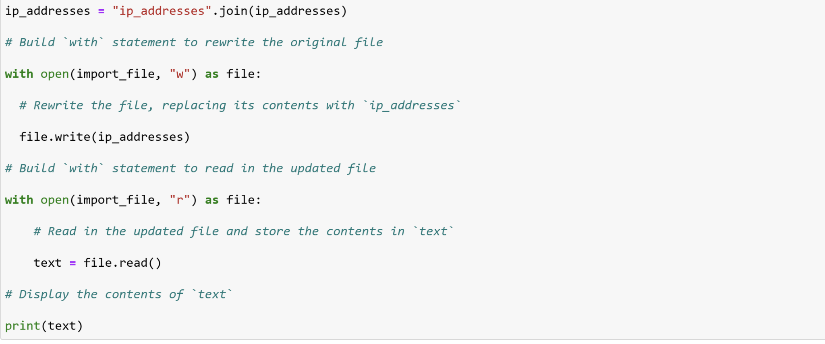

After it writed as a ip_addresses to make sure we use with function and import_file to read a a file and we store it in text file and display it as text now.

## Summary

As what i’ve learned from this i think it would make my work faster as for the help of python for using the removing, adding files, making to read the files, and joining the file.